Mobile Application Development

Assignment 4.

18309003 Roh sung ho

18309008 Nabil Madih

Function 1. Splash Screen Function

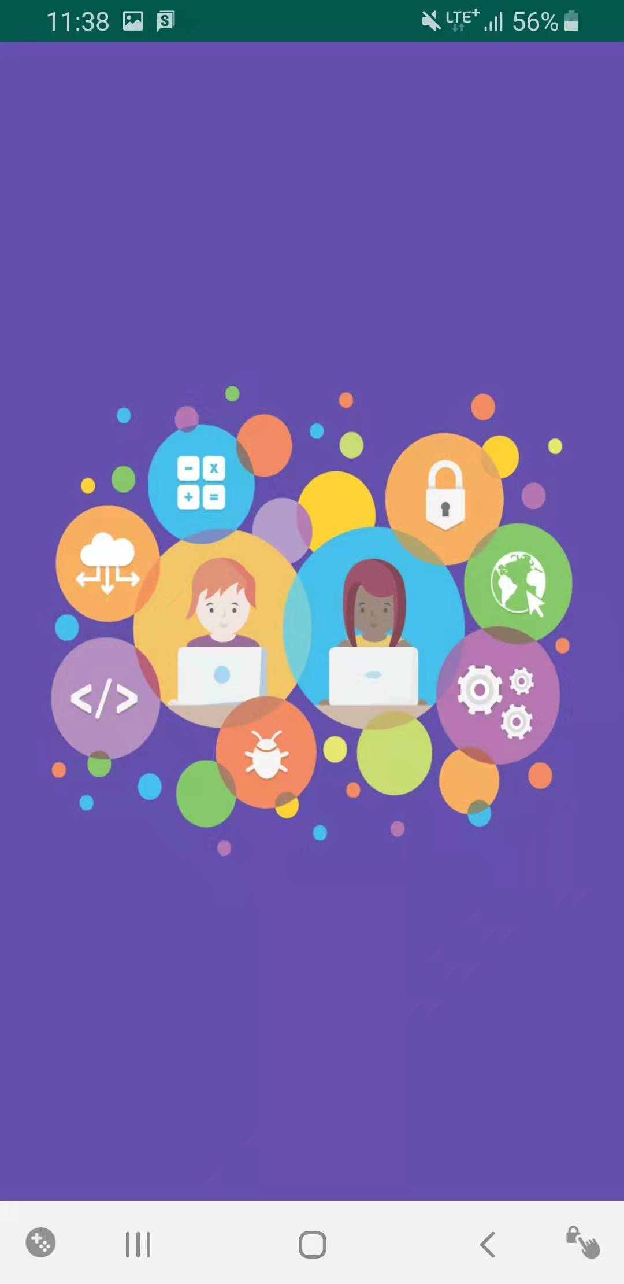

We made simply splash screen.

when the app works, the first screen will be shown like this.

